This article shows how to get internet to Beagle Bone Black (BBB) connected via USB cable.

**How to get internet for the Beagle Bone Black ->** [**Link to getting Internet**](https://ofitselfso.com/BeagleNotes/HowToConnectBeagleboneBlackToTheInternetViaUSB.php)

If done as instructed in this article you will get internet on BBB, if in any case you are not getting the internet while pinging 8.8.8.8 or pinging google.com then it may be the issue of the windows network not issuing the proper IP address for BBB.

Make the changes in the Control Panel -> Network -> Make the below changes on the Ethernet Adapter (Beagle Bone Connection) and the adapter which you are getting internet (For me it’s Wifi-2 in this)

**This is for your internet connection adapter settings -> enable the sharing and in the dropdown select the Beagle bone adapter, for me it is Ethernet 2.**

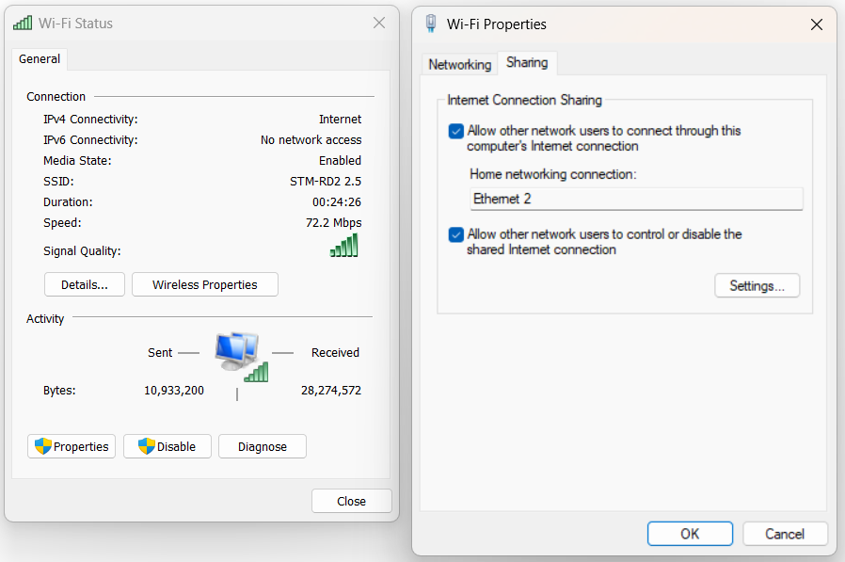

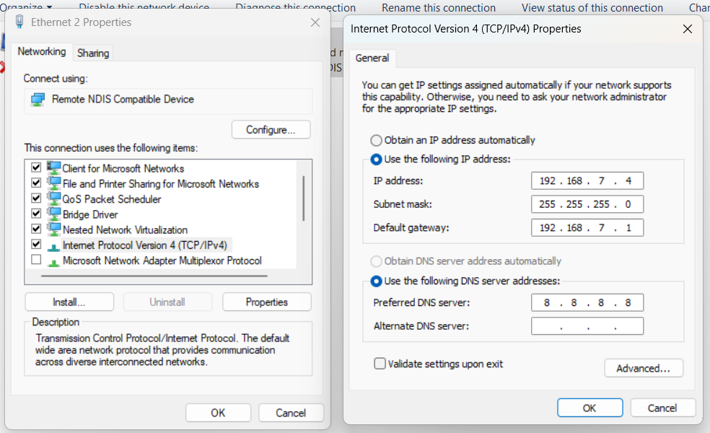These settings is for the Ethernet 2 (BBB), go to the BBB adapter in the network adapter window, and select properties -> Double click Internet Protocol Version 4(TCP/IPv4) -> You’ll get the window shown in the right image, make the setting as per the same network i.e. the first 3 numbers of the IP should be same i.e. 192.168.7.x (you can put anything within 254 at x position) Click OK. And done.

* After Connecting the BBB, run this command and add the below 2 lines in that file.

**$ sudo nano /etc/resolv.conf**

nameserver 8.8.8.8

nameserver 8.8.4.4

Save and exit (Ctrl + O, enter, Ctrl + X)

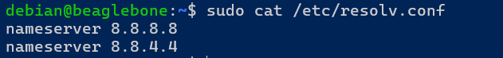

This is after the editing the file, this is mainly done to get the internet through nameserver i.e. ping google.com should work.

* After this run this command ->

**$ sudo nano /etc/sysctl.conf**

Uncomment this line in that file

net.ipv4.ip_forward=1

Save and exit (Ctrl + O, enter, Ctrl + X)

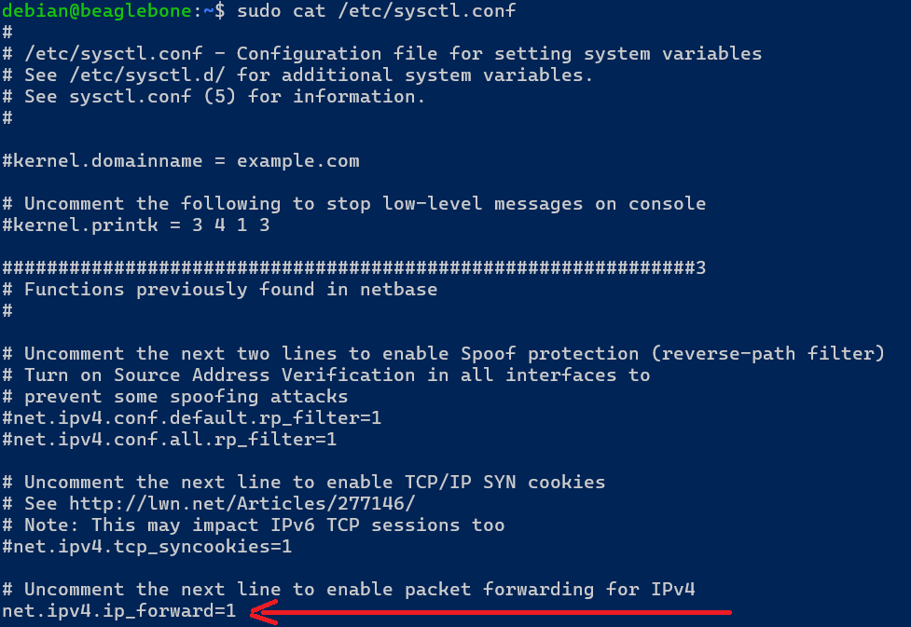Uncomment the line shown in the image.

After this reboot once and you should get internet on your beagle bone black.